

**VFEP SMF**

## Attendees

|  |  |  |
| --- | --- | --- |
| **Stakeholder** | **Department** | **E-mail Address** |
| Brian Grubb | UAT Tester | [Brian.Grubb@va.gov](mailto:Brian.Grubb@va.gov) |
| Cinda Quattrini | UAT Tester | [cinda.quattrini@va.gov](mailto:cinda.quattrini@va.gov) |
| Jodie Balder | UAT Tester | [Jodie.Balder@va.gov](mailto:Jodie.Balder@va.gov) |
| Darla van Nieukerk | OI&T | [Darla.vanNieukerk@va.gov](mailto:Darla.vanNieukerk@va.gov) |
| Kara Ciprich | VFEP - Contractor | [KARA.CIPRICH@va.gov](mailto:KARA.CIPRICH@va.gov) |
| Vish Ashok | VFEP - Contractor | [Vishnhav.Ashok@va.gov](mailto:Vishnhav.Ashok@va.gov) |
| Donna Saunders | VFEP - Contractor | [donna.saunders@va.gov](mailto:donna.saunders@va.gov) |
| Fatma Khan | VFEP - Contractor | [fatma.khan@va.gov](mailto:fatma.khan@va.gov) |
| Napoleon Kernessant | VFEP - Contractor | [Napoleon.Kernessant@va.gov](mailto:Napoleon.Kernessant@va.gov) |
| Garry Forbes | VFEP - Contractor | [Garry.Forbes@va.gov](mailto:Garry.Forbes@va.gov) |
| Gregg Puhala | VFEP - Contractor | [GREGG.PUHALA@va.gov](mailto:GREGG.PUHALA@va.gov) |
| Noah Stern | VFEP - Contractor | [NOAH.STERN@va.gov](mailto:NOAH.STERN@va.gov) |
| Ariana Adili | VFEP - Contractor | [ARIANA.ADILI@va.gov](mailto:ARIANA.ADILI@va.gov) |

## Test Coverage

|  |  |
| --- | --- |
| **STAGING** | |
| [GI Bill Comparison Tool | Veterans Affairs (va.gov)](https://staging.va.gov/education/gi-bill-comparison-tool/)  **(This page can be accessed with or without authentication)** | |
| **Jira Ticket (Front/Back)** | **Requirement Title** |
| VFEP-1097 | Change "Jump to community focus details" to "Go to community focus details" |
| VFEP-1077 | Add "Clear filters" button to left side filters after initial search by name and search by location |
| VFEP-931(void) | School types and other filter should not have prechecks |
| VFEP-1056 | Move search to left side panel after initial search completed - search by location |
| VFEP-930 | Update SMF Filter Definitions |
| VFEP-929 | Update SMF filter titles |
| VFEP-927 | Change name of SMF to "Community Focus" |
| VFEP-939 | Move search to left side panel after initial search completed |
| VFEP-938 | Condense Search/filter area |
| VFEP-1096 | Remove Learn Mores on SMF |

## Test Environment

1. Staging
2. [GI Bill Comparison Tool | Veterans Affairs (va.gov)](https://staging.va.gov/education/gi-bill-comparison-tool/)
3. **Summary (Defects) – 0. (All internal testing passed successfully before UAT in Staging).**
4. Coverage for References – 100%. (All SMF related user stories have respective tests completed to ensure 100% coverage before UAT).

## Terms/Acronyms

Make a mention of any terms or acronyms used in the project

| TERM/ACRONYM | DEFINITION |
| --- | --- |
| SMF | Special Mission Filters |
| HBCU | Historically Black Colleges and Universities |
| HSI | Hispanic-Serving Institutions |
| TCU | Tribal Colleges and Universities |
| AANAPISI | Asian American and Native American Pacific Islander-Serving Institutions |
| PBI | Predominantly Black Institutions |
| ANSI | Alaska Native-Serving Institutions |
|  |  |

## Accessbility Coverage

| JIRA ID | DEFINITION | Resolution Date | Resolution Details |
| --- | --- | --- | --- |
| VFEP-932 | Accessibility on additional heading structure on filters | 01/24/2024 | Pass |
| VFEP-933 | Accessibility change filter heading structure | 01/23/2024 | Pass |
| VFEP-934 | Accessibility learn more headings | 01/23/2024 | Pass |
| VFEP-935 | Accessibility switch filter links to buttons | 01/23/2024 | Pass |
| VFEP-936 | Accessibility Learn more button/link specificity | 01/18/2024 | Pass |
| VFEP-1121 | Accessibility Heading structure changes for | 02/05/2024 | Pass |

GitHub Accessibility Testing Checklist

* Document submitted on – 02/05/2024.
* GitHub submission reference number (If applicable) - <https://github.com/department-of-veterans-affairs/va.gov-team/issues/new?assignees=briandeconinck&labels=a11y-testing&template=a11y-testing.yaml&title=Accessibility+Testing+for+%5BTeam+Name%2C+Product+Name%2C+Feature+Name%5D>

## SMF Stories

**UAT Activities**

Execution -> Test all items from list below.

VFEP-1097

|  |  |  |  |  |
| --- | --- | --- | --- | --- |
| # | STEP | PASS | FAIL | UAT Notes |
| 1 | Navigate to GI Comparison tool location 🡪 [GI Bill® Comparison Tool | Veterans Affairs (va.gov)](https://staging.va.gov/education/gi-bill-comparison-tool/) |  |  |  |
| 2 | Under ‘*Community Focus’,* validate on the search by name and the search by location tabs, the Jump to community focus details is renamed to Go to community focus details. See Example A. |  |  |  |

Example A

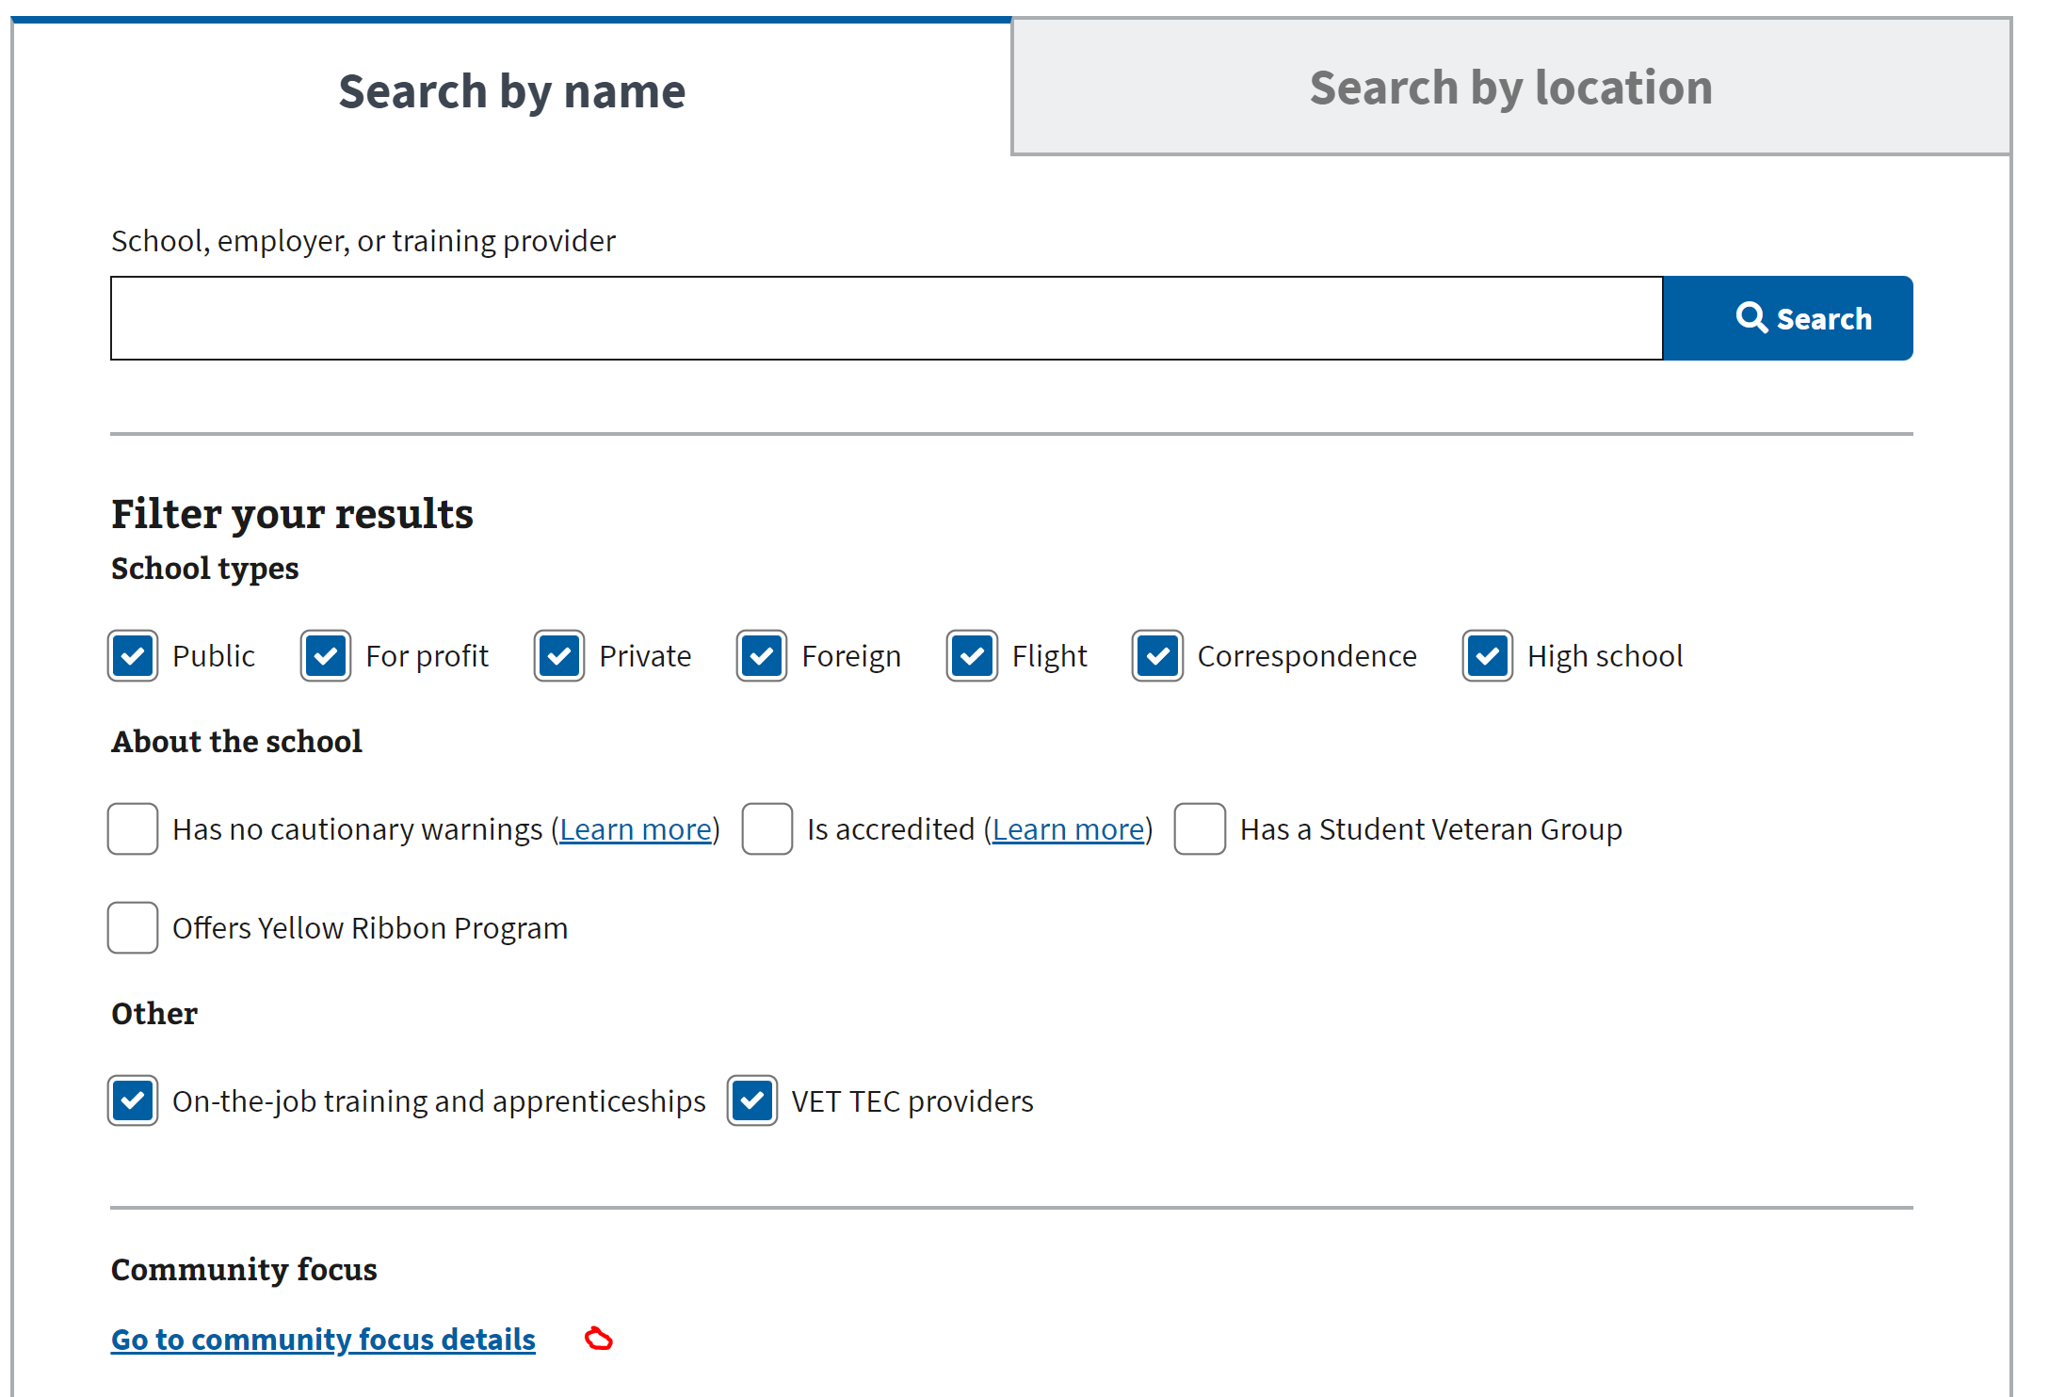

VFEP-1077

|  |  |  |  |  |
| --- | --- | --- | --- | --- |
|  | STEP | PASS | FAIL | UAT Notes |
| 1 | **Navigate to GI Comparison tool location 🡪** [GI Bill® Comparison Tool | Veterans Affairs (va.gov)](https://staging.va.gov/education/gi-bill-comparison-tool/) |  |  |  |
| 2 | On the landing page of the Compare tool, under search by name and the search by location, validate that the ‘Clear Filters’ button can be seen.  For an additional verification, please select multiple ‘*Community Focus’* Filters as well.  Note: ‘Clear Filters’ button on landing page initially found under Community focus section. |  |  |  |
| 3 | Upon clicking on the ‘Clear Filters’ button, validate that the above pre-selected filters under school types (ex. Public, For Profit) are now Unchecked. **See Example B.** |  |  |  |
| 4 | Under the text box ‘*School, employer, or training provider*’ Type in any input and hit the Search button. |  |  |  |
| 5 | Note: Filter Your Results section has now moved to the left with all the search results now occupying the center of the page.  Under Filter Your Results, at random select different checkboxes to narrow down the search. Validate that clicking on the ‘Clear Filters’ button located at the bottom clears all selected filters (checkboxes). See Example C. |  |  |  |
| 6 | Navigate to ‘Search by Location’ tab. See Example D.  Validate that on the landing page, clicking on ‘Clear Filters’ button clears all pre-selected filters. (All selected filters from Search by Name/Search by Location will be cleared if one of them is cleared. |  |  |  |
| 7 | Search for a zip-code or location on the Search by Location tab. Upon the search results appearing on the page, validate that the ‘*Filter Your Results*’ has moved to the left-hand side of the page. Expand the section and click on the ‘Filter Results’ button on the bottom. Validate that all pre-selected checkboxes have been removed. See Example E. |  |  |  |

**Example B Example C**

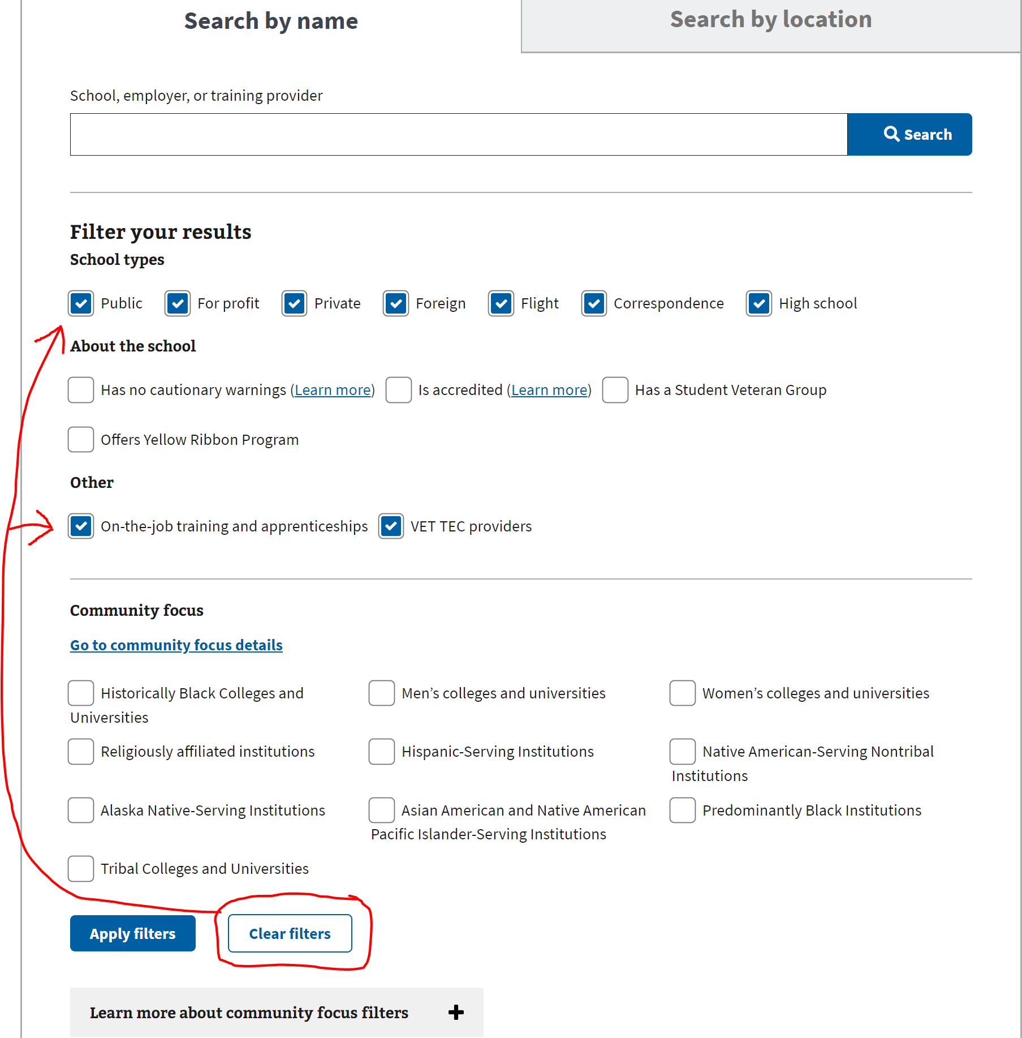 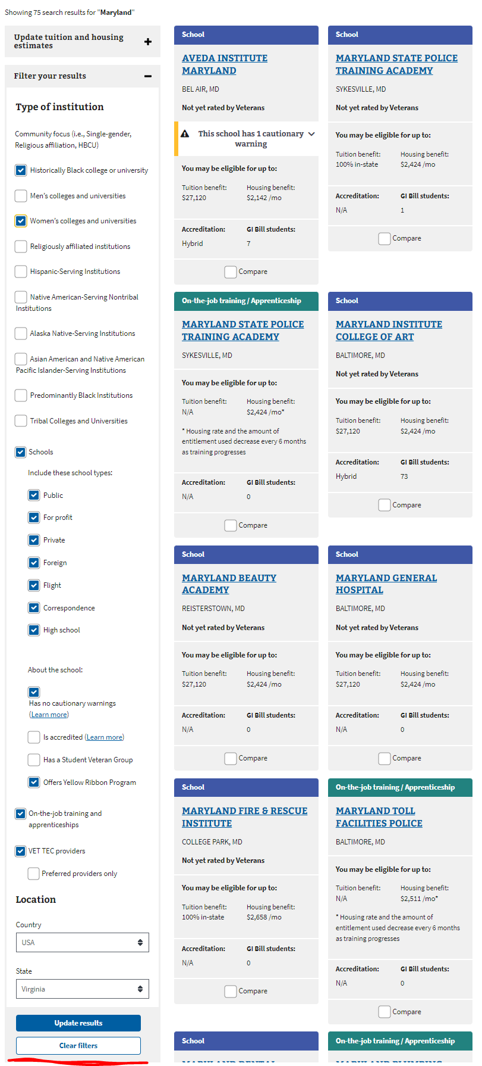 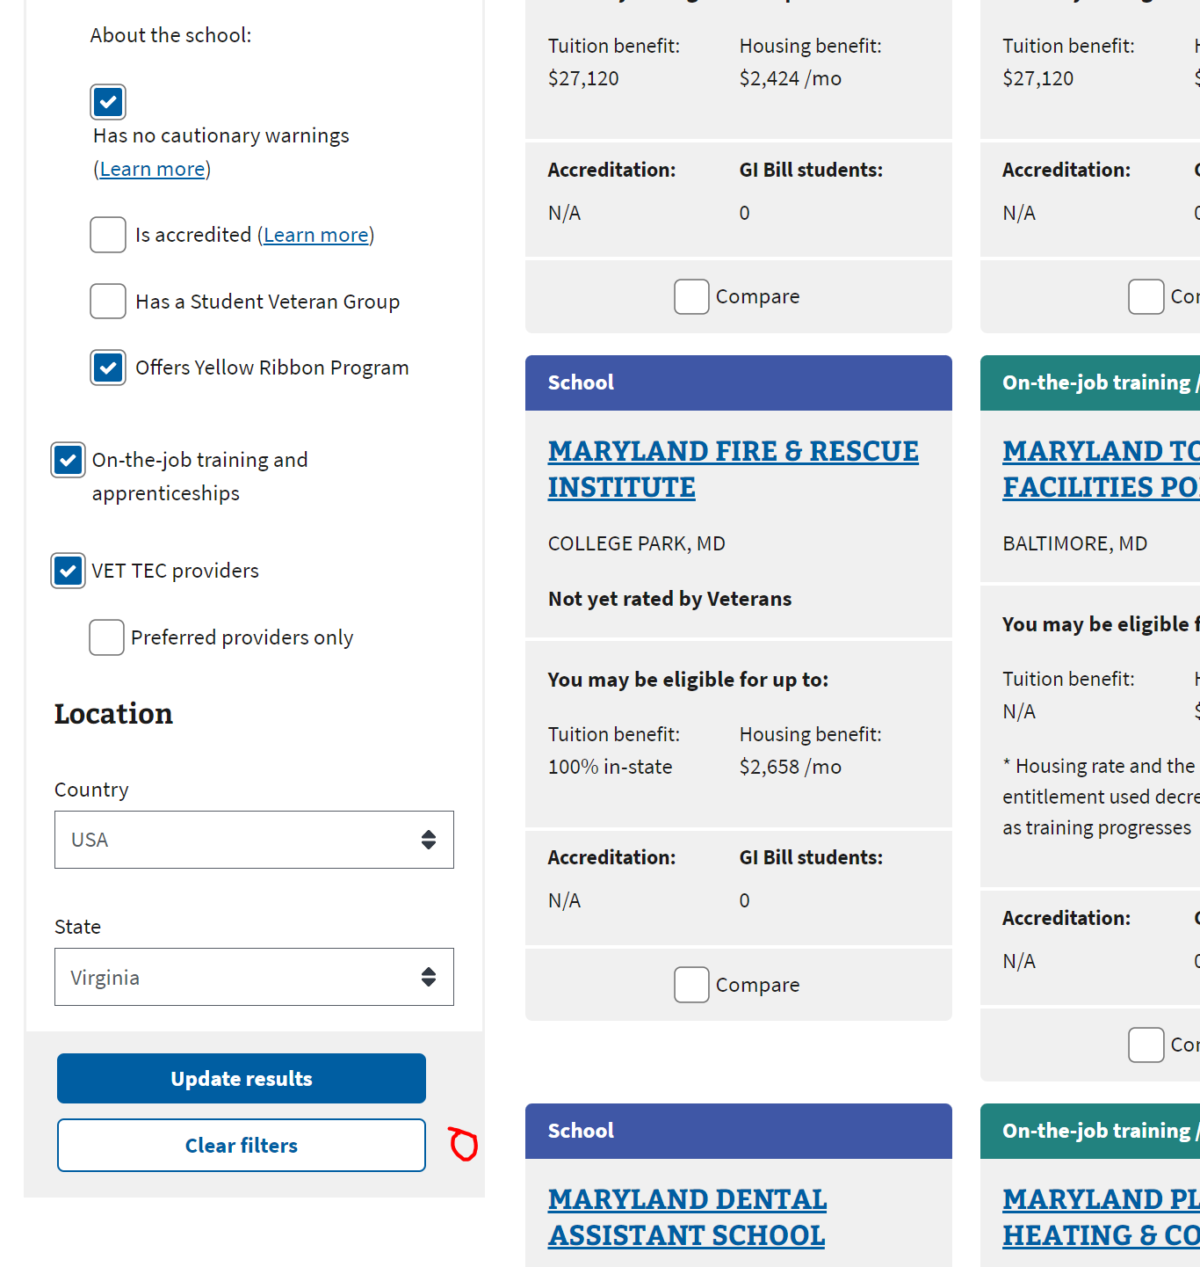

**Example D Example E**

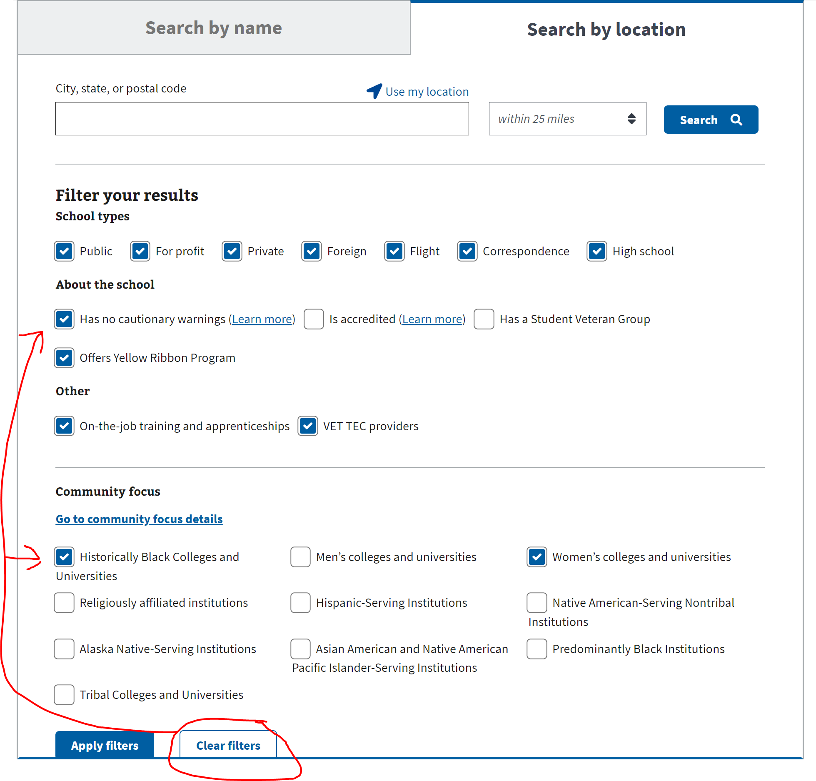 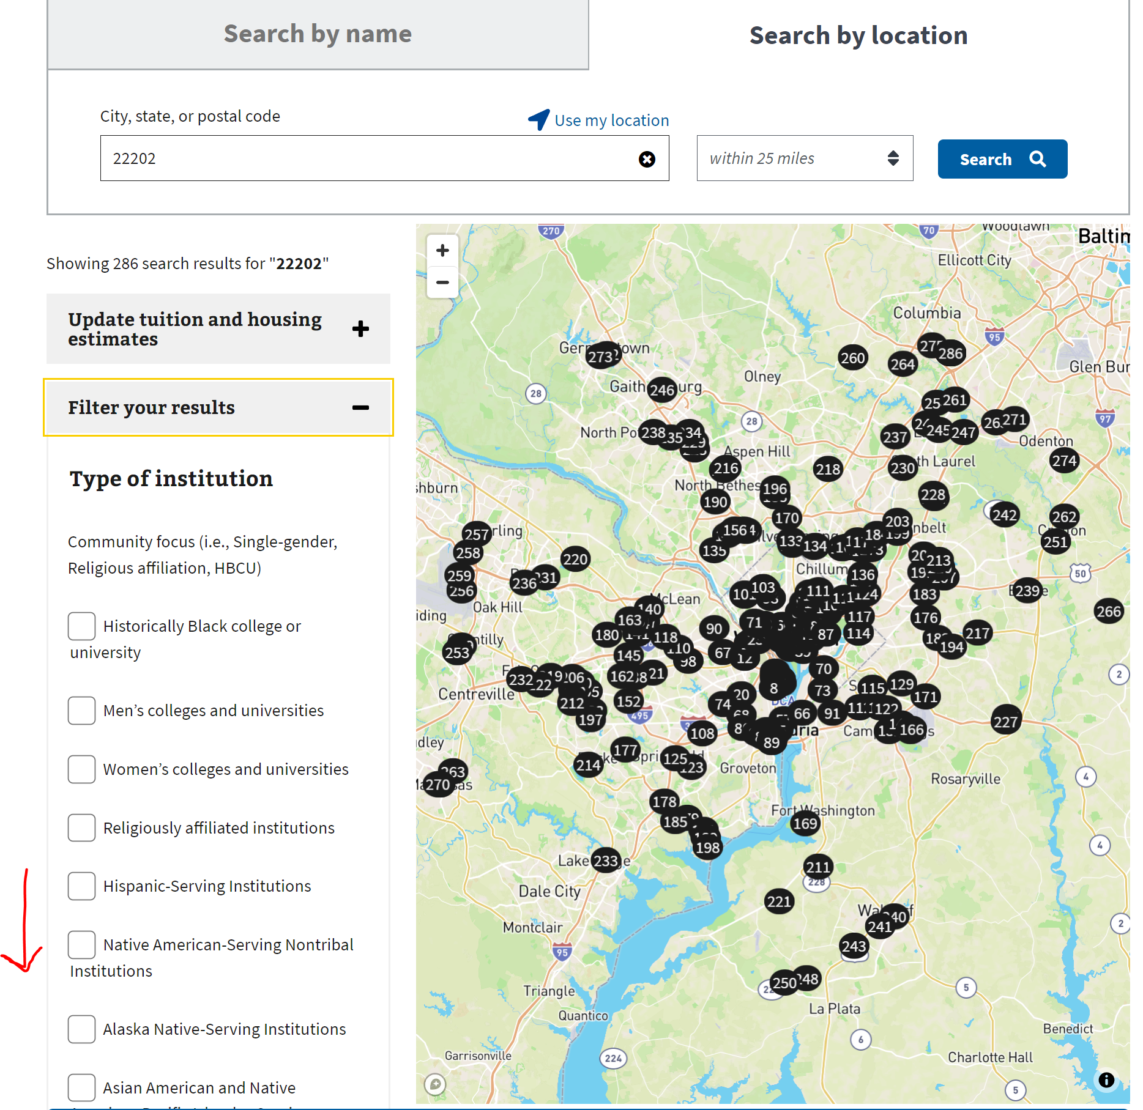

VFEP-1056

|  |  |  |  |  |
| --- | --- | --- | --- | --- |
| # | STEP | PASS | FAIL | Additional Notes |
| 1 | **Navigate to GI Comparison tool location 🡪** [GI Bill® Comparison Tool | Veterans Affairs (va.gov)](https://staging.va.gov/education/gi-bill-comparison-tool/) |  |  |  |
| 2 | **On Search by Name & Search by Location**.  Search for a text/school/location on either of the tabs. Validate that the ‘Filter Your Results’ section has been moved to the left-hand side of the page after clicking on the Search button. |  |  |  |

Example D

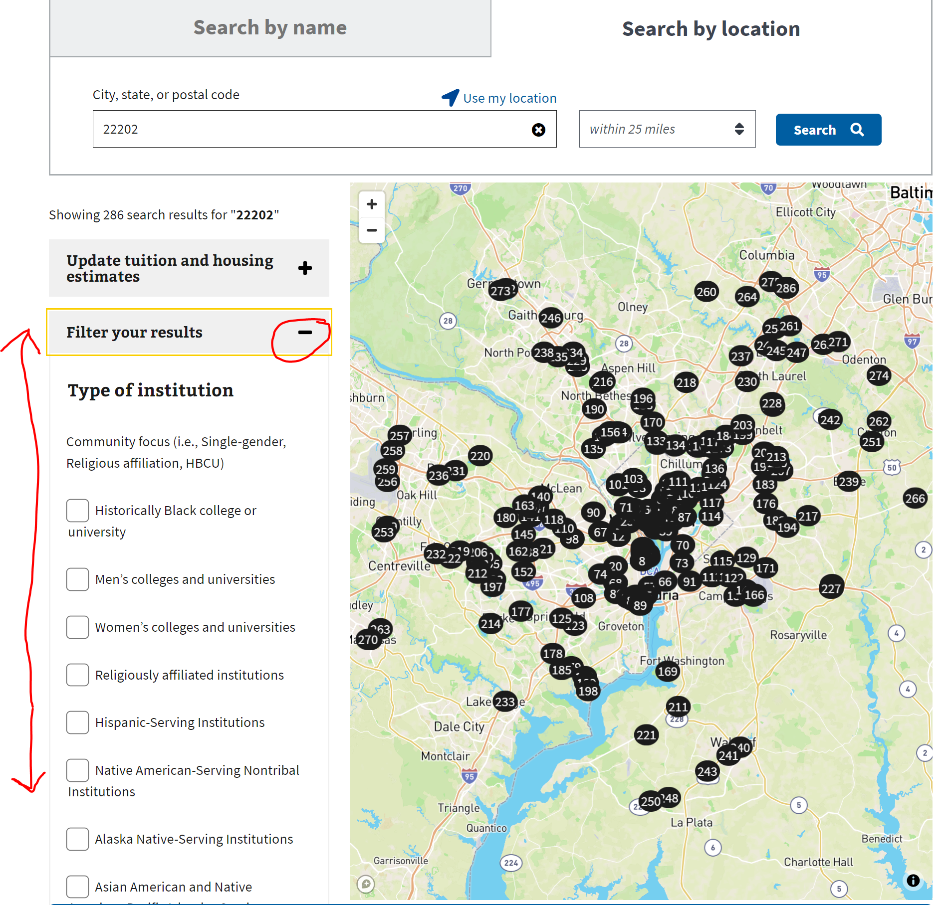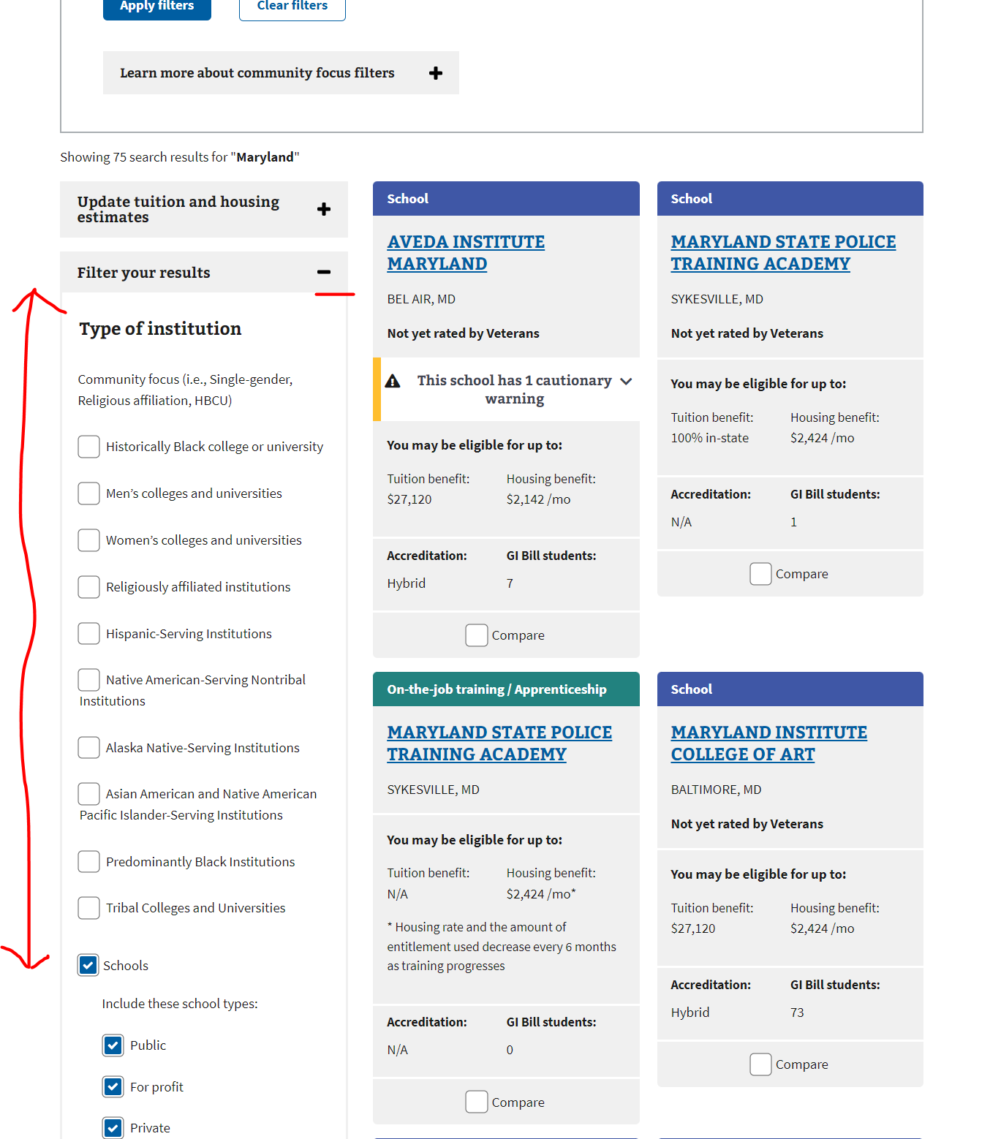

VFEP-930

|  |  |  |  |  |
| --- | --- | --- | --- | --- |
| # | STEP | PASS | FAIL | Additional Notes |
| 1 | **Navigate to GI Comparison tool location 🡪** [GI Bill® Comparison Tool | Veterans Affairs (va.gov)](https://staging.va.gov/education/gi-bill-comparison-tool/) |  |  |  |
| 2 | Scroll down to ‘*Learn more about community focus filters’* OR click on the hyperlink ‘*Go to community focus details ‘.*  Validate that this section can be expanded or expanded upon clicking on the hyperlink.  Validate that the following definition have been updated based on STEP 3. See Example F. |  |  |  |
| 3 | The new definitions are listed as follows:   * Alaska Native-Serving Institutions   An Alaska Native-Serving Institution (ANSI) is a college or university that receives federal funding to help serve Alaska Native students. At least 20 percent of the school’s full-time undergraduate students identify as Alaska Native.   * Asian American Native American Pacific Islander-Serving Institutions   An Asian American Native American Pacific Islander-Serving Institution (AANAPISI) is a college or university that receives federal funding to help serve Asian Americans and Native American Pacific Islanders and low-income students. At least 10 percent of the school’s full-time undergraduate students identify as Asian American and Native American Pacific Islander.   * Hispanic-Serving Institutions   A Hispanic-Serving Institution (HSI) that receives federal funding to help serve Hispanic and low-income students. At least 20 percent of the school’s full-time undergraduate students identify as Hispanic.   * Predominantly Black Institutions   A Predominantly Black Institution (PBI) receives federal funding to help serve black students, as well as low-income and first-generation students. At least 40 percent of the school’s undergraduate students are Black.   * Tribal Colleges and Universities   Tribal Colleges and Universities (TCUs) are schools that tribal nations and the federal government set up to serve Native American and Alaskan Native students. Most TCUs are on or near reservation lands.   * Religiously affiliated institutions   A religiously affiliated institution identifies with a specific religious group.  Note: The new definition is listed in the learn more drop down menu |  |  |  |

Example F

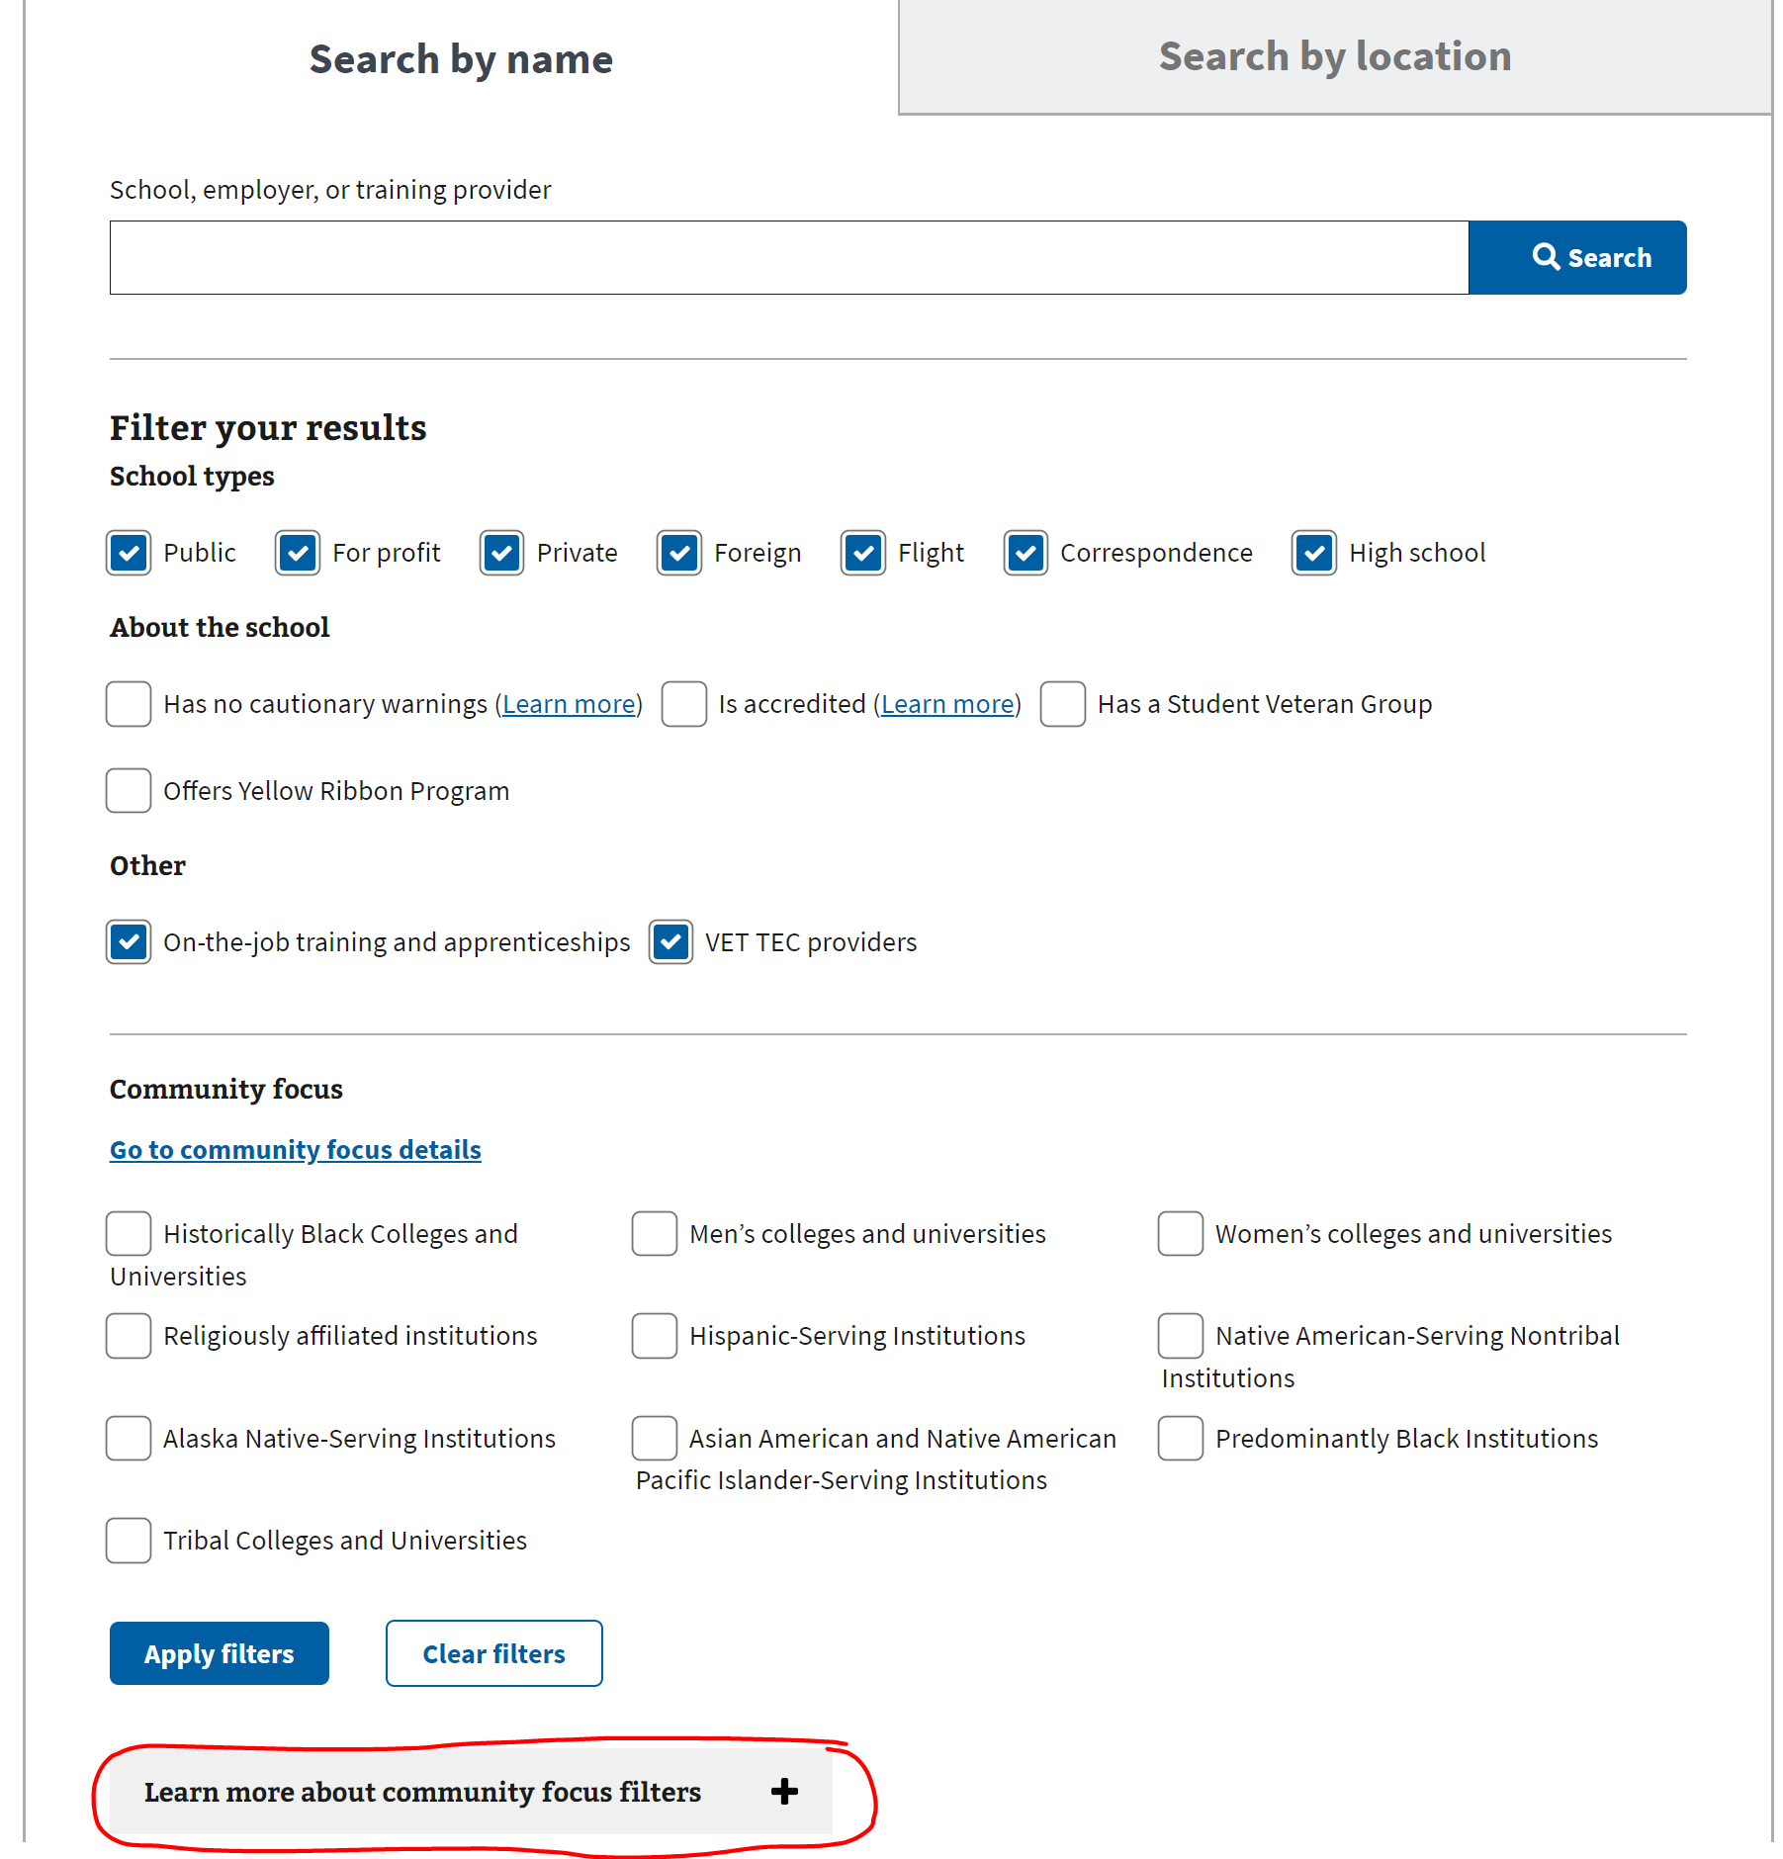

VFEP-929

|  |  |  |  |  |
| --- | --- | --- | --- | --- |
| # | STEP | PASS | FAIL | Additional Notes |
| 1 | **Navigate to GI Comparison tool location 🡪** [GI Bill® Comparison Tool | Veterans Affairs (va.gov)](https://staging.va.gov/education/gi-bill-comparison-tool/) |  |  |  |
| 2 | * Under *‘Community Focus’* section for Search by Name & Search by Location, Validate that the new filter option titles read as follows   + Alaska Native-Serving Institutions   + Asian American and Native American Pacific Islander-Serving Institutions   + Hispanic-Serving Institutions   + Historically Black Colleges and Universities   + Native American-Serving Nontribal Institutions   + Predominantly Black Institutions   + Tribal Colleges and Universities   + Men’s colleges and universities   + Women’s colleges and universities   + Religiously affiliated institutions   See Example G |  |  |  |
| 3 | * The new filter titles appear on the Search by Name tab. * The new filter titles appear on the Search by Location tab. * The new filter titles appear on the Search by Name tab search results page. * The new filter titles appear on the Search by Location tab search results page. |  |  |  |

Example G

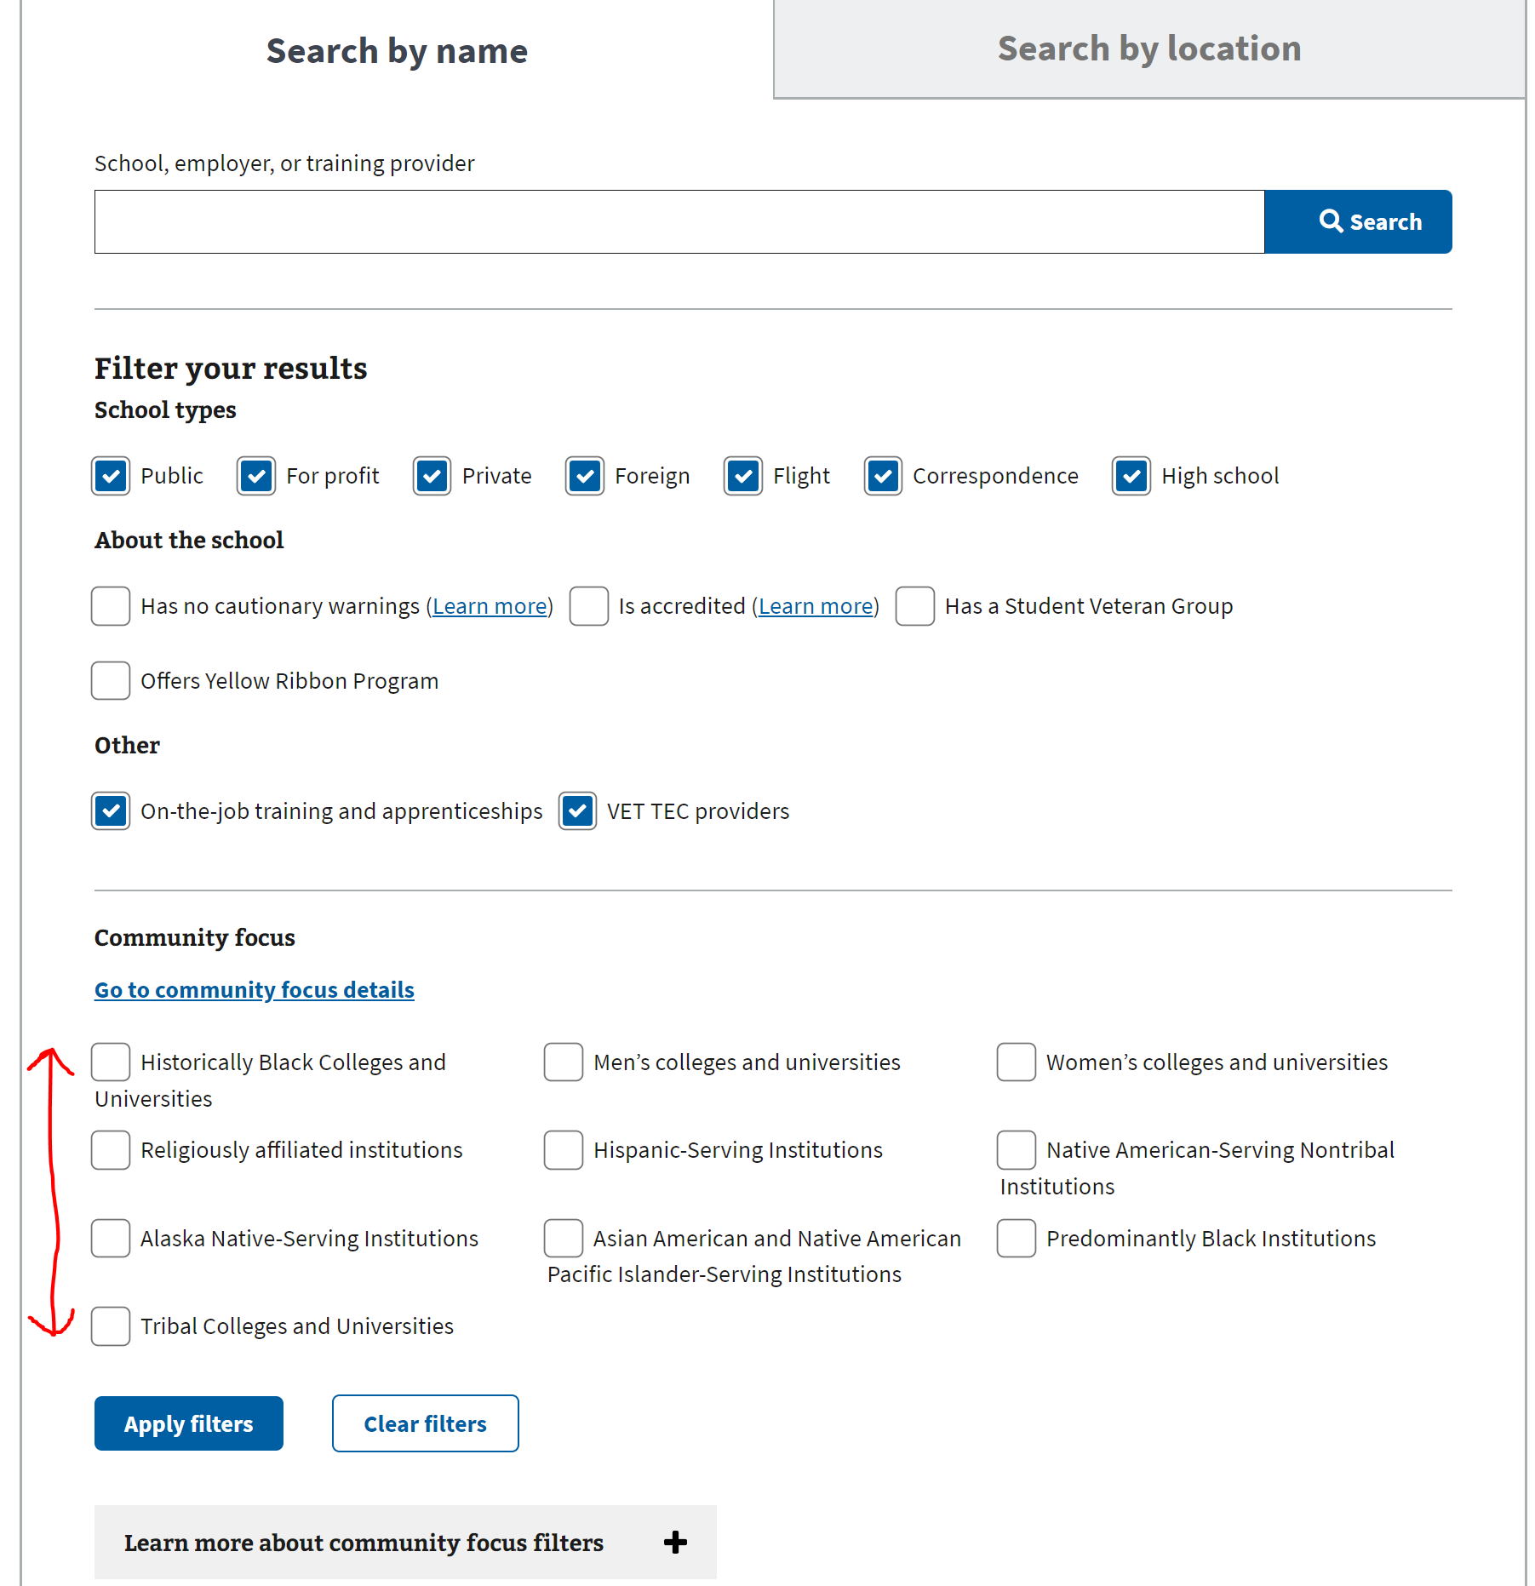

VFEP-927

|  |  |  |  |  |
| --- | --- | --- | --- | --- |
| # | STEP | PASS | FAIL | Additional Notes |
| 1 | **Navigate to GI Comparison tool location 🡪** [GI Bill® Comparison Tool | Veterans Affairs (va.gov)](https://staging.va.gov/education/gi-bill-comparison-tool/) |  |  |  |
| 2 | Below steps contain all the places where the word ‘Specialized’ is replaced with ‘Community’.  Validate the section is named "Community Focus" on the Search by Name tab with the jump to renamed. See Example H. |  |  |  |

Example H

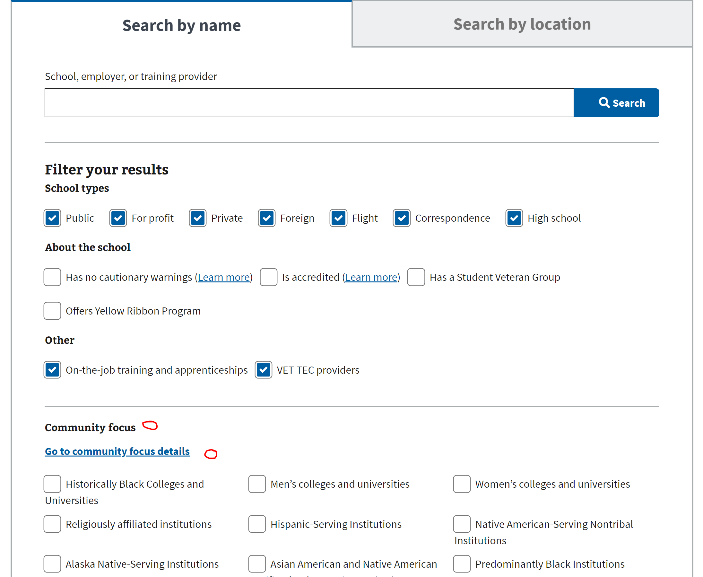

|  |  |  |  |  |
| --- | --- | --- | --- | --- |
| # | STEP | PASS | FAIL | Additional Notes |
| 3 | Validate the section is named "Community Focus" on the Search by Location tab with the jump to renamed. See Example I. |  |  |  |

Example I

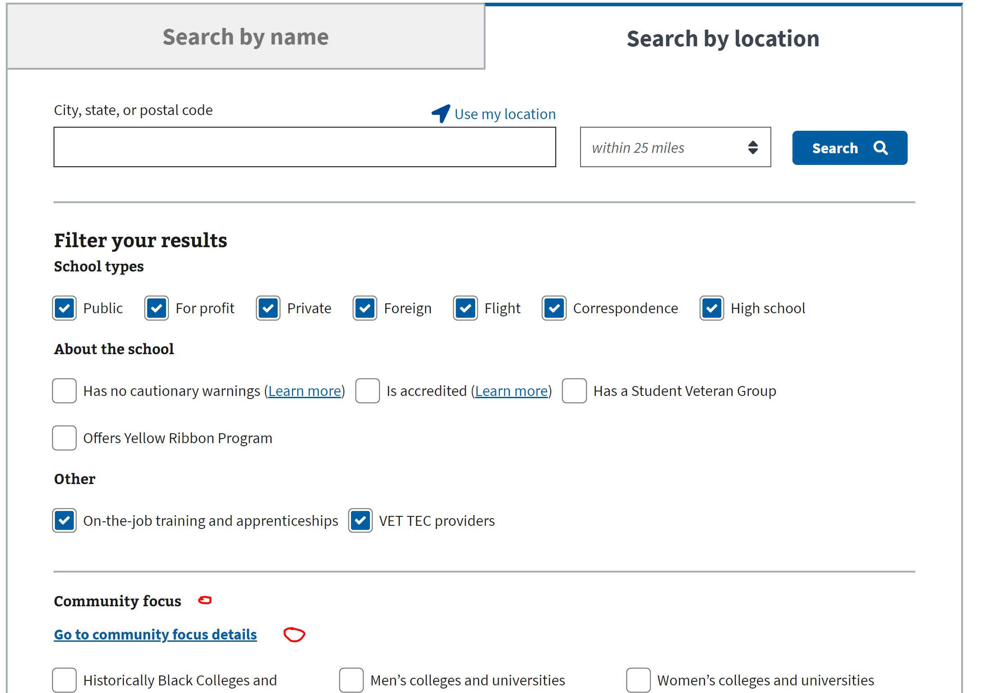

|  |  |  |  |  |
| --- | --- | --- | --- | --- |
| # | STEP | PASS | FAIL | Additional Notes |
| 4 | Validate that the search by name section learn more is renamed from "Learn more about specialized missions" to "Learn more about community focus filters". See Example J. |  |  |  |
| 5 | Validate that the Institution comparison label for Specialized mission is changed to Community focus. See Example K.  Note- Select up to 3 schools/universities to compare and click on ‘*Compare*’ button. |  |  |  |

Example J Example K

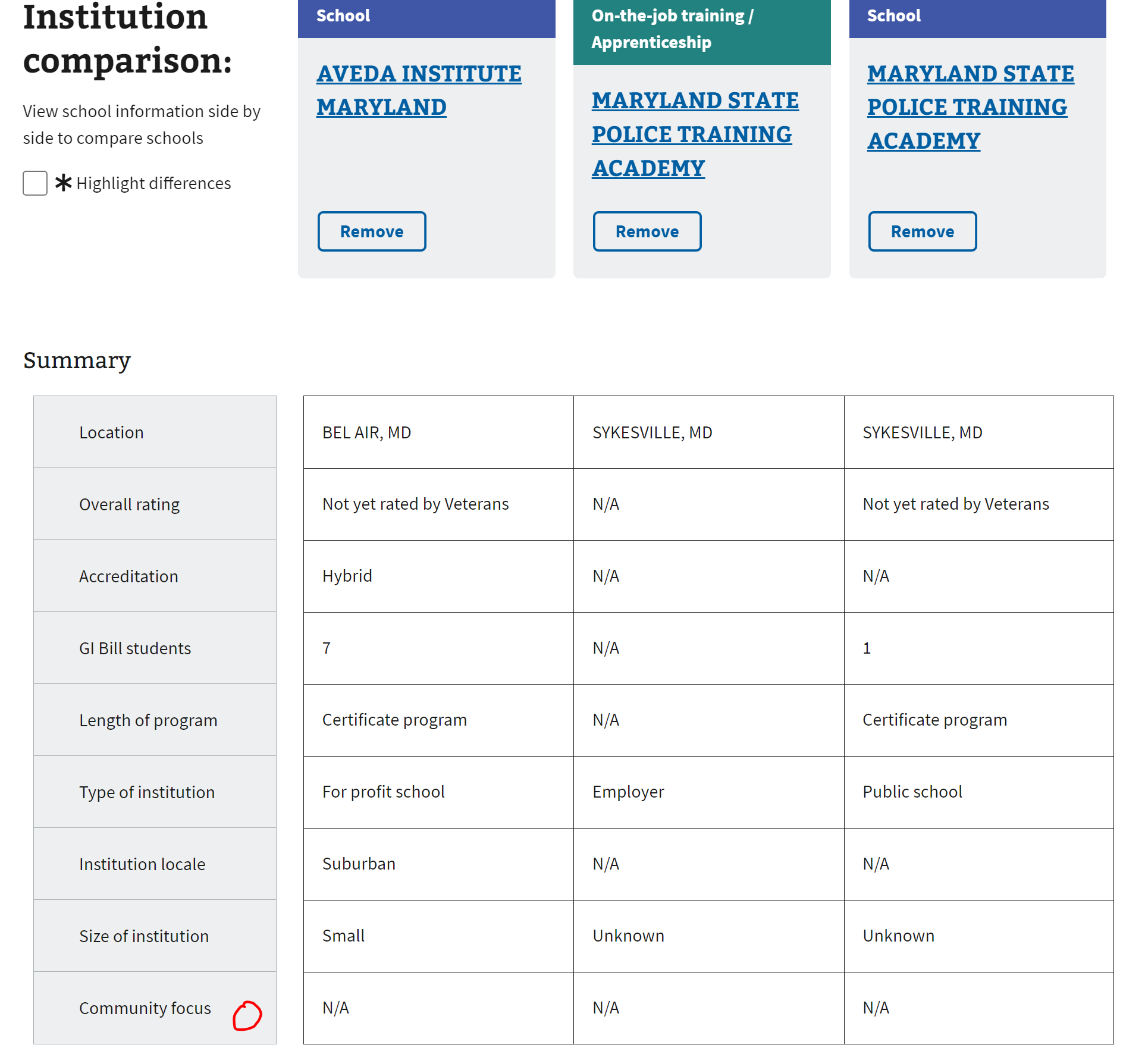

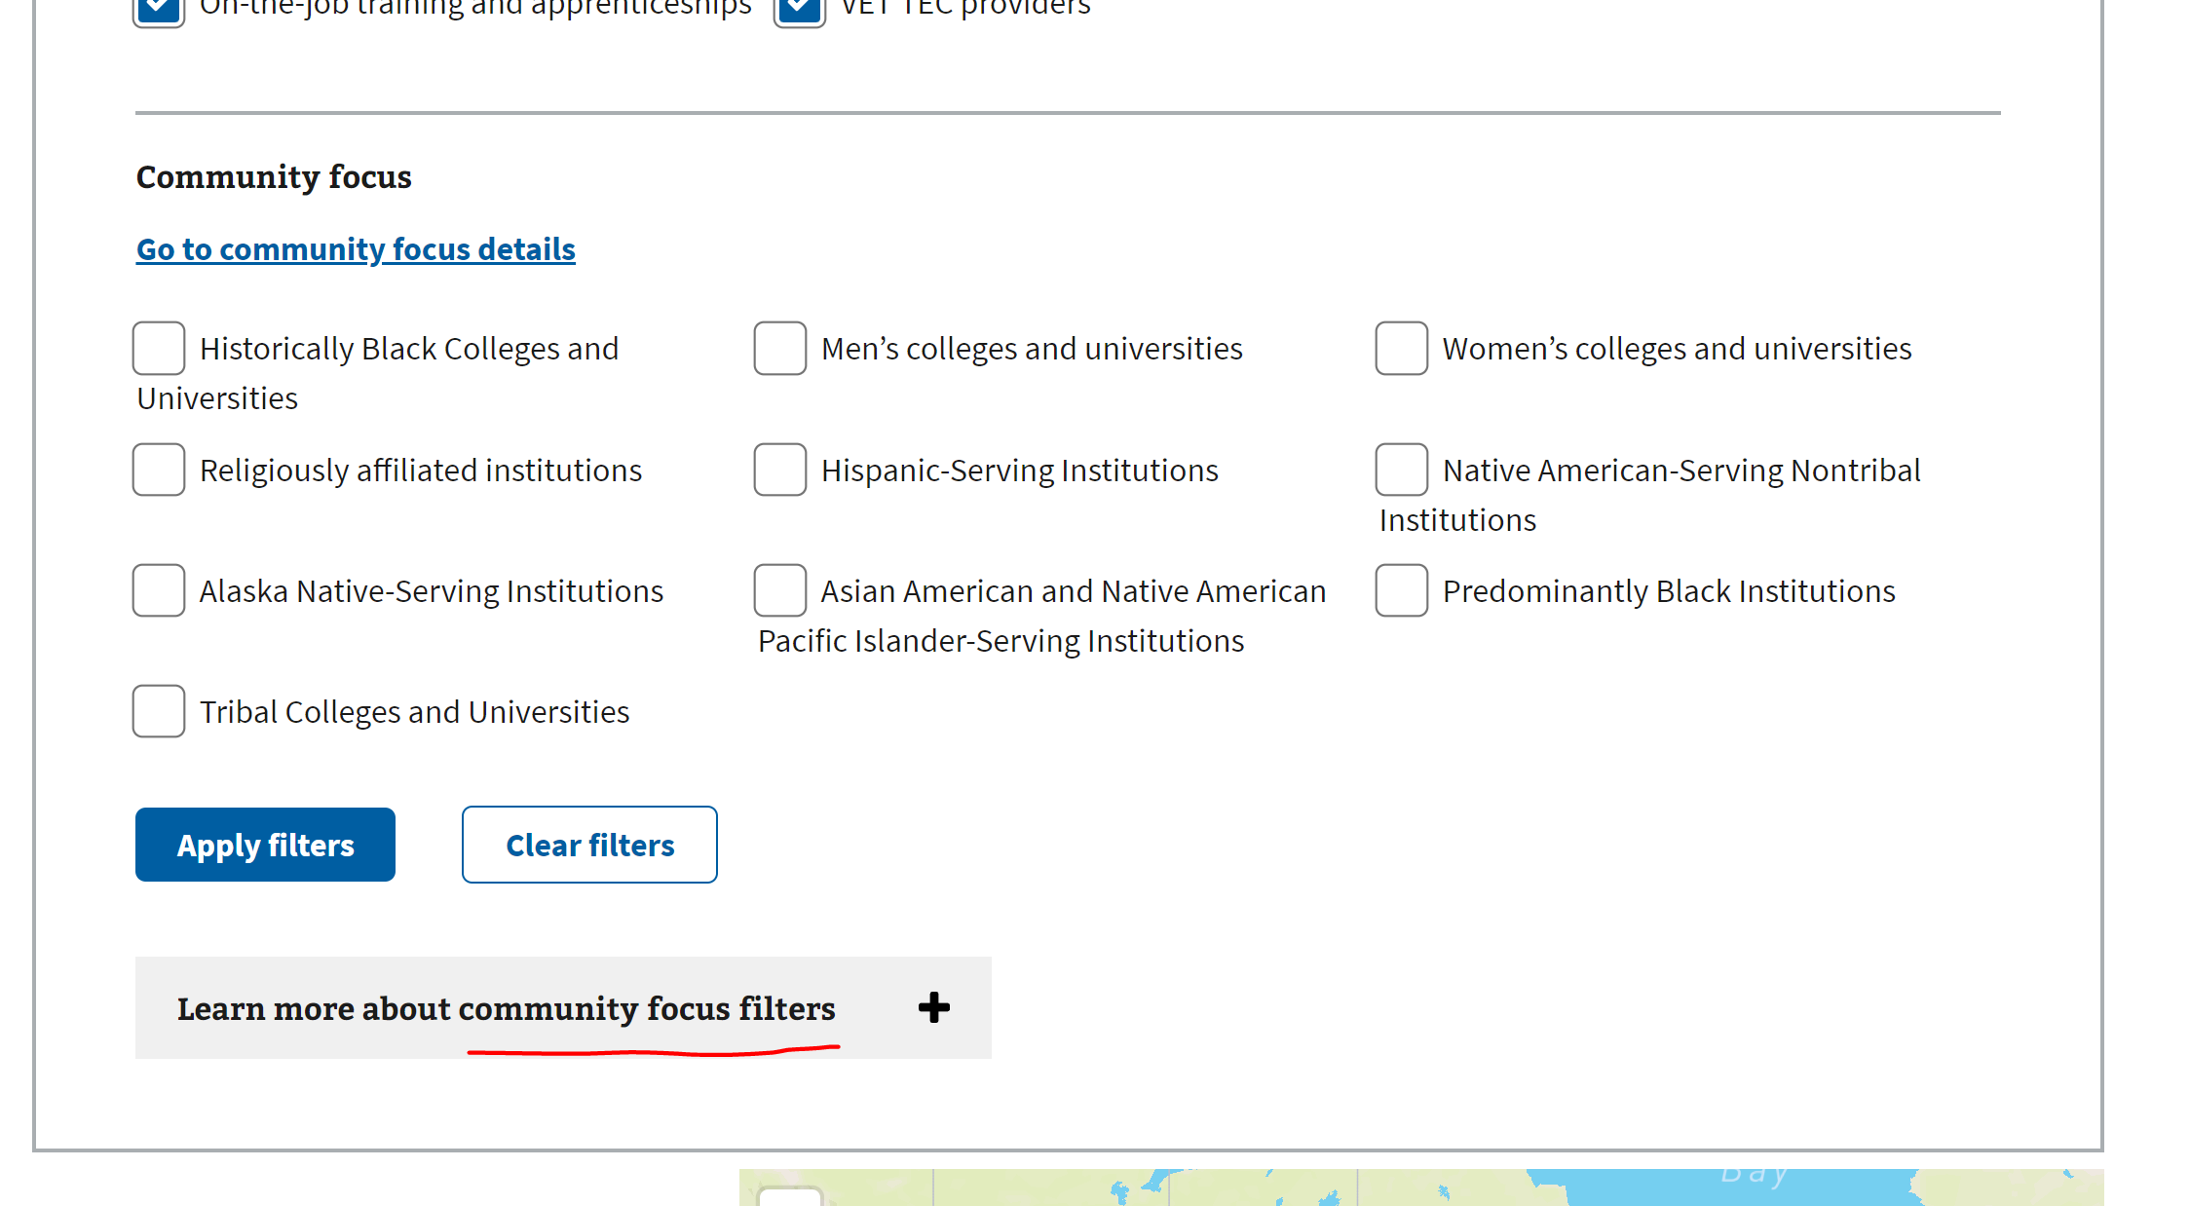

|  |  |  |  |  |
| --- | --- | --- | --- | --- |
| # | STEP | PASS | FAIL | Additional Notes |
| 6 | The additional information on the comparison summary fields is changed. Click on the drop-down ‘*Additional information on comparison summary fields*’ and scroll till the bottom of the expanded section. See Example L. |  |  |  |

Example L

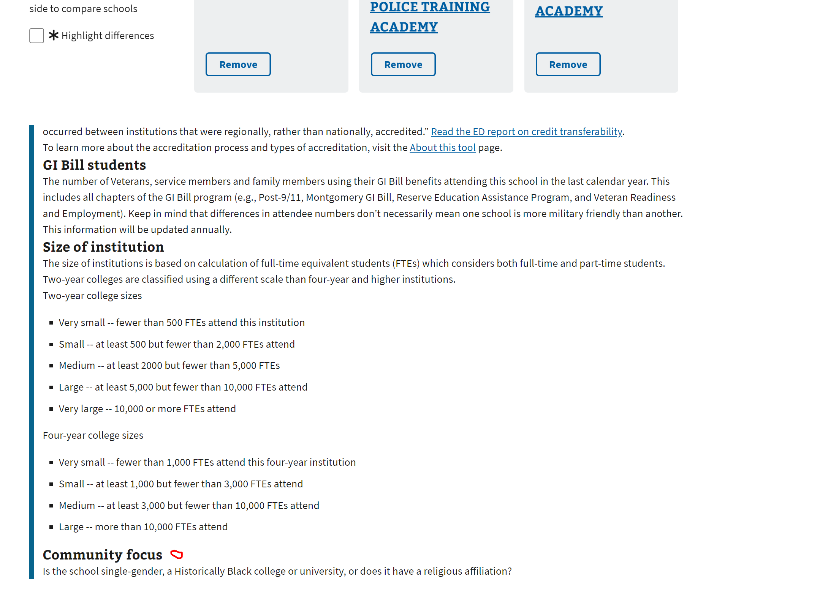

VFEP-1096

|  |  |  |  |  |
| --- | --- | --- | --- | --- |
| # | STEP | PASS | FAIL | Additional Notes |
| 1 | **Navigate to GI Comparison tool location 🡪** [GI Bill® Comparison Tool | Veterans Affairs (va.gov)](https://staging.va.gov/education/gi-bill-comparison-tool/) |  |  |  |
| 2 | For both ‘Search by Name’ & ‘Search By Location’ The SMF learn more links for Has no cautionary warnings and Is accredited are removed from the top of the search and on the left side of the search.  Validate that the ‘Learn More’ hyperlink placed after all the ‘*Filter Your Results*’ are removed. See Example M. |  |  |  |

Example M

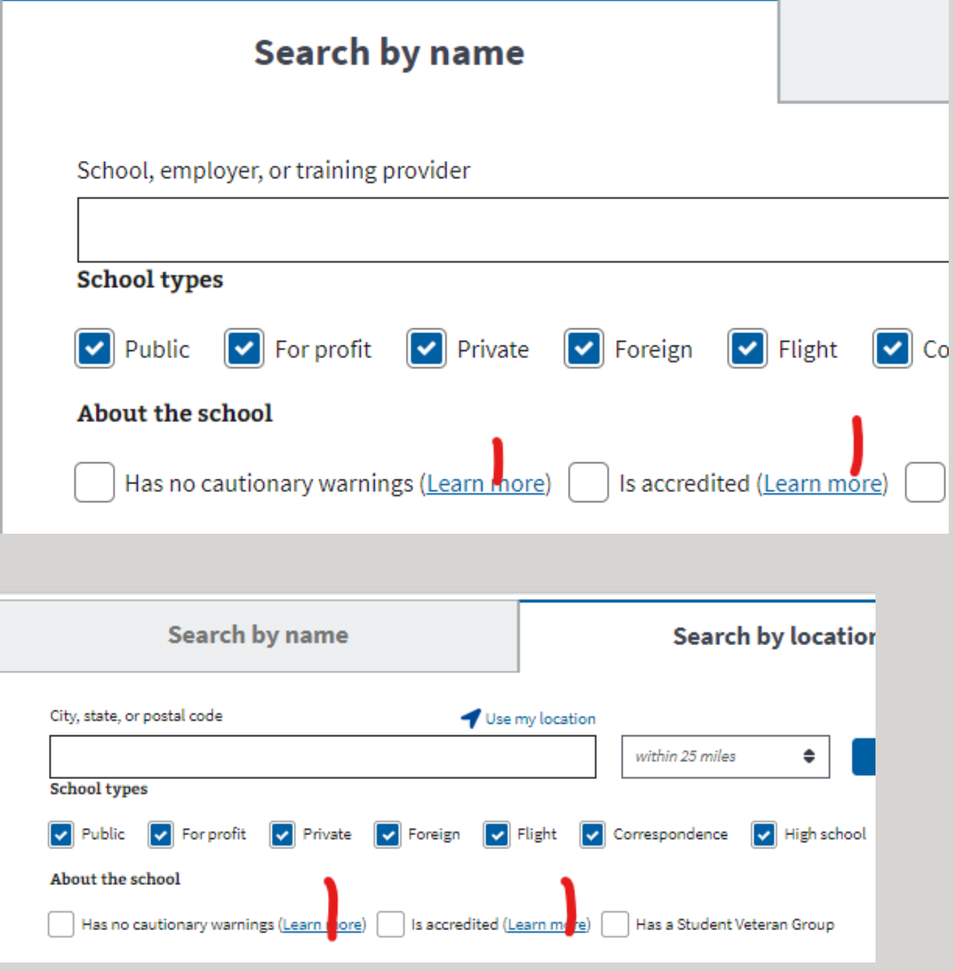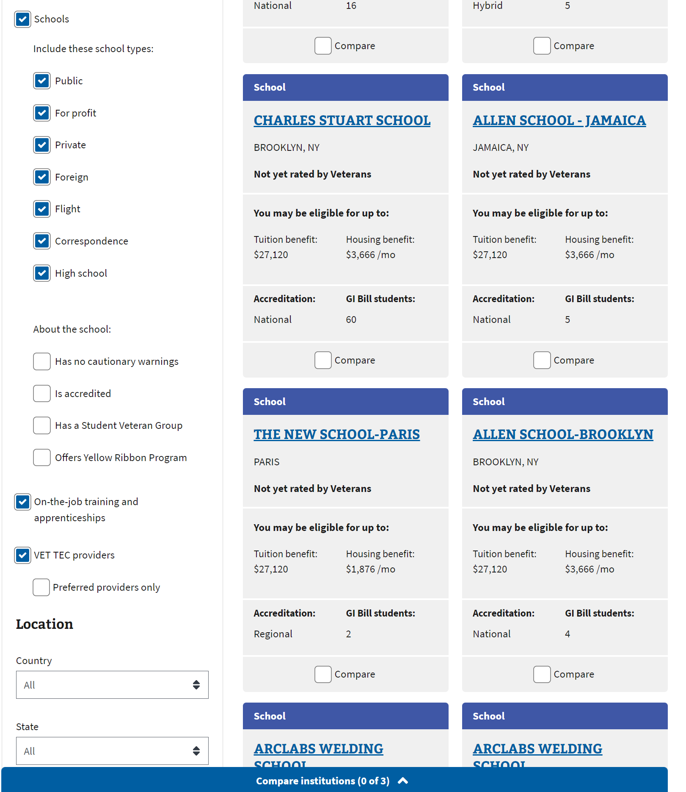

VFEP-938

|  |  |  |  |  |
| --- | --- | --- | --- | --- |
| # | STEP | PASS | FAIL | Additional Notes |
| 1 | **Navigate to GI Comparison tool location 🡪** [GI Bill® Comparison Tool | Veterans Affairs (va.gov)](https://staging.va.gov/education/gi-bill-comparison-tool/) |  |  |  |
| 2 | For both ‘Search by Name’ & ‘Search By Location’ The amount of white space between fields on the screen below is reduced to provide more screen real-estate.  Visual validation is shown in BEFORE (See Example N) & AFTER (See Example O).  . |  |  |  |

Example N Example O

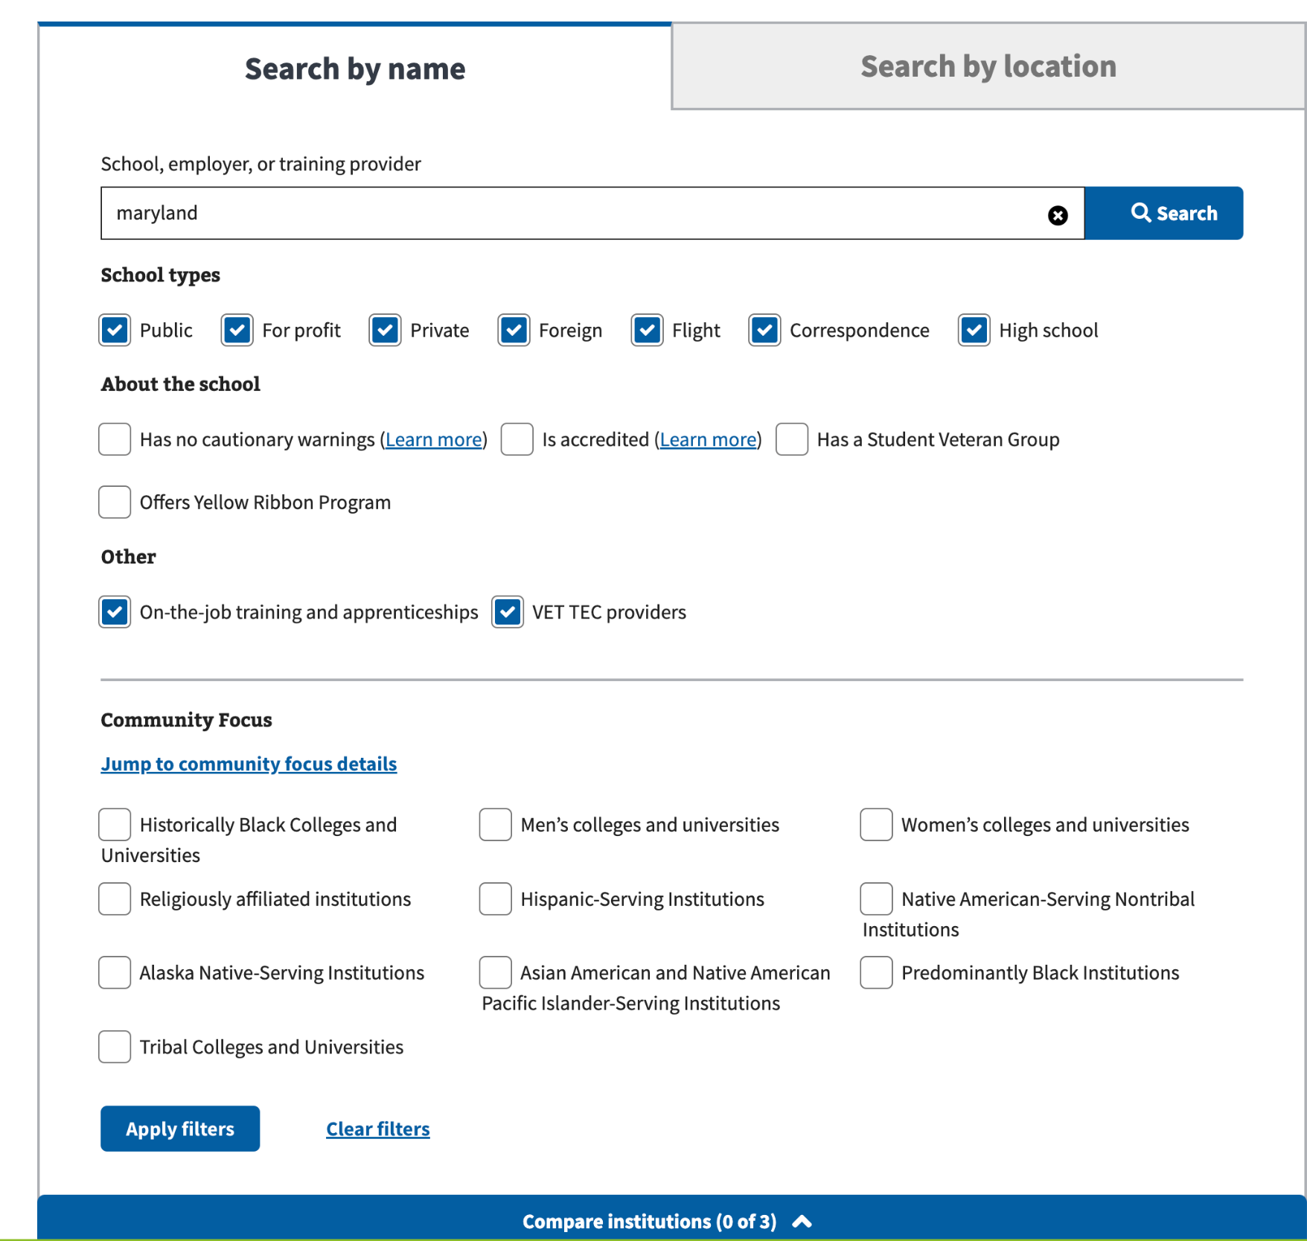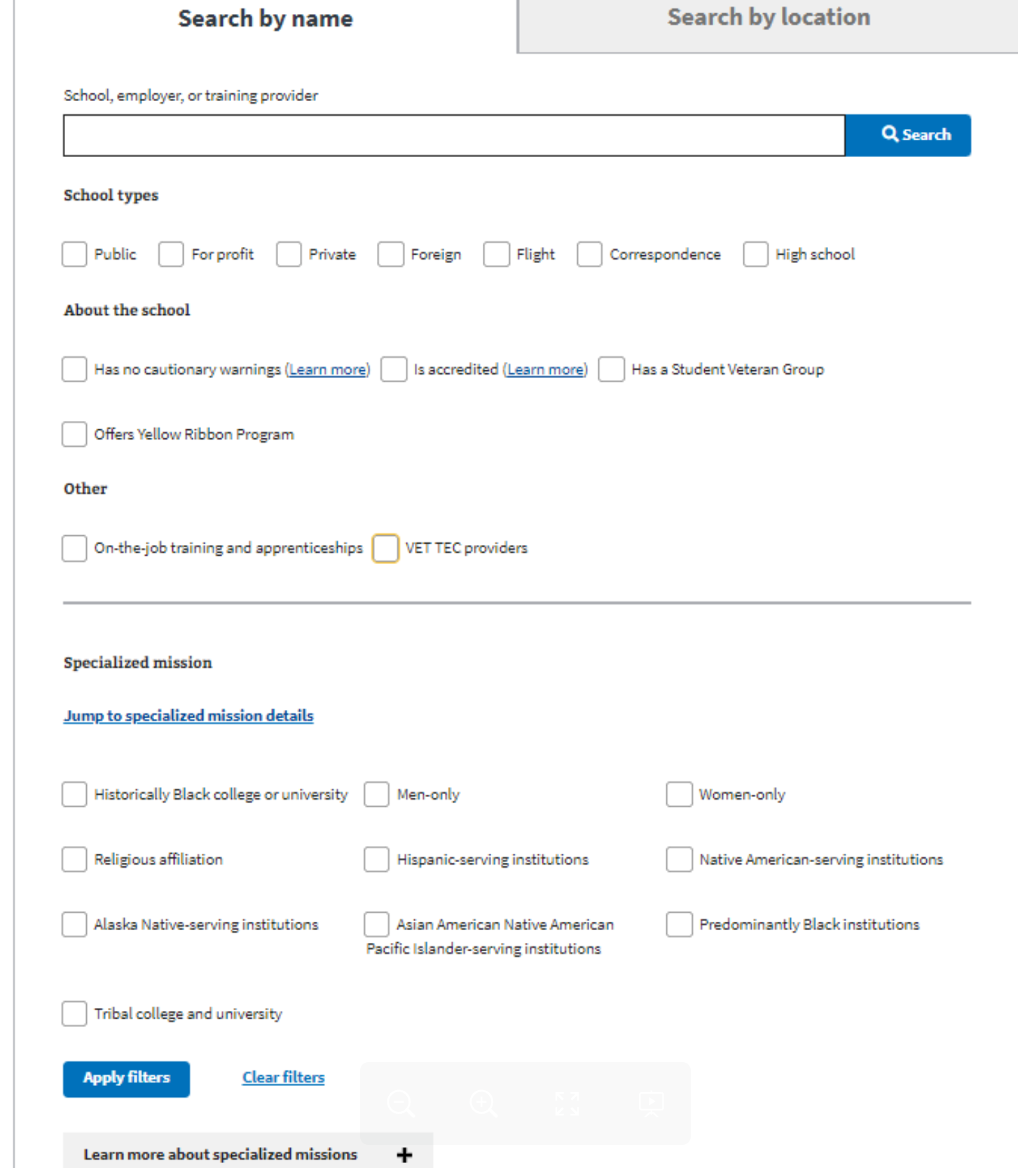

VFEP-939

|  |  |  |  |  |
| --- | --- | --- | --- | --- |
| # | STEP | PASS | FAIL | Additional Notes |
| 1 | **Navigate to GI Comparison tool location 🡪** [GI Bill® Comparison Tool | Veterans Affairs (va.gov)](https://staging.va.gov/education/gi-bill-comparison-tool/) |  |  |  |
| 2 | For both ‘Search by Name’ & ‘Search By Location’, enter a text input in the Search bar. Upon clicking on the Search button, Validate that all the Filter options have now been moved to the left-hand side of the page.  See Example P. |  |  |  |

Example P

